##### **COURSEWORK ASSIGNMENT**

# Team Project on Healthy Habitat Network

|  |  |
| --- | --- |
| **Module Title:** Software Development Exercise | **Module Code:** 7COM1081 |
| **Assignment Title:** CW1 Team Project and Individual Project Reflection Report | **Group:** 23 |
| **Tutor**: Dr Javed Ali Khan | **Submission Date**: 28/04/2025 |

# Team Number: 23

|  |  |
| --- | --- |
| **Student ID Number:** | **Year Code:** |
| 23076470 (Joyal James) | 2024-2025 |
| 24005640 (Hasan Kasmani) | 2024-2025 |
| 23038283 (Babatunde Hope Oluwatoyosi) | 2024-2025 |
| 23100508 (Jahnavi Dharmesh Chokshi) | 2024-2025 |
| 24004693 (Umesh Shahu Shrestha) | 2024-2025 |

Table of Contents

1. Executive Summary 4

2. Introduction 4

3. Discussion on Project Management 4

4. Functional Requirements 5

5. Non-Functional Requirements 7

6. Outcome 10

7. Roles and Responsibilities 10

8.Trello Screenshots 11

# 1. Executive Summary

The Healthy Habitat Network project aimed to develop a PHP-based prototype platform linking health-conscious residents with businesses offering wellness and sustainable living products/services.   
Using MySQL, PHP, HTML, CSS, and JavaScript, the team developed a system featuring user registration, area management, business/product listings, voting functionality, and filtering options.  
Effective project management was achieved through task assignment, Kanban board tracking (Trello), and regular communication. The project delivered a functional, scalable, and user-friendly prototype meeting both functional and non-functional requirements.

# 2. Introduction

Healthy Habitat Network is an internet-based prototype for a non-profit organization that promotes health, wellness, and sustainable lifestyles among communities. It connects environmentally conscious residents with green enterprises, providing a virtual platform that encourages individuals and families to engage in healthy and nature-friendly lifestyle choices.  
  
The platform serves as a bridge connecting the residents and local SMEs that provide wellness services and sustainable products. Residents are able to browse, register, and vote for products or services that they feel will add value to their wellness. Meanwhile, SMEs receive useful information on local demand and can sell their differentiated products directly to the potential crowd.  
  
Built using PHP, MySQL, HTML, CSS, and JavaScript, the prototype includes features such as user registration, services and product listings, area management, and a voting system that highlights popular wellness options. It includes filtering, admin controls, and usability options that complement core design principles.

# 3. Discussion on Project Management

We applied a methodical and team-based approach to manage the design development of the Healthy Habitat Network prototype. To begin with, we had a planning session to demarcate project requirements and assign tasks based on strengths. These included frontend and backend development, database design, project management, and documentation.

We employed Trello with a Kanban board to keep track of tasks, grouping them into columns: "To do," "In progress," and "Done." Each task, like "Create resident registration," "Design database," or "Add voting feature," was assigned to a team member with a checklist and due date. It helped ensure openness and continuous progress.

Regular check-ins via chat and virtual meetings helped us stay on track and address issues quickly. We also checked each other's work, which helped improve the quality and usability of the prototype.

For managing versions, we were regularly copying our files and shared resources to a shared folder. The group collaborated on task – like the backend developer and UI lead collaborated on improving form validation and layout.

In general, our communication, task management, and teamwork enabled us to complete all the required features, adhere to deadlines, and ensure equal contributions from everyone. The process also improved our collaboration and problem-solving abilities.

# 4. Functional Requirements

1. Add new area  
2. Add new resident  
3. Associate resident with area  
4. Add new product or service to existing business  
5. Register new business (SME)  
6. Apply one product/service per business rule  
7. Add new vote by resident  
8. Allow multiple votes per resident (one per product/service)  
9. Edit existing product or service details  
10. Filter products by category/type  
11. Filter products by category and price under £200  
12. Display total votes per product/service  
13. Rank products/services by number of "yes" votes  
14. Link products to certifications (e.g., organic, non-GMO)  
15. Log resident interests (i.e., diet, exercise)  
16. Select resident areas from a pre-defined list  
17. Admin facility for adding areas (local authority)  
18. Prevent voting on unavailable products  
19. Show most visited products/services per area

# Home Page

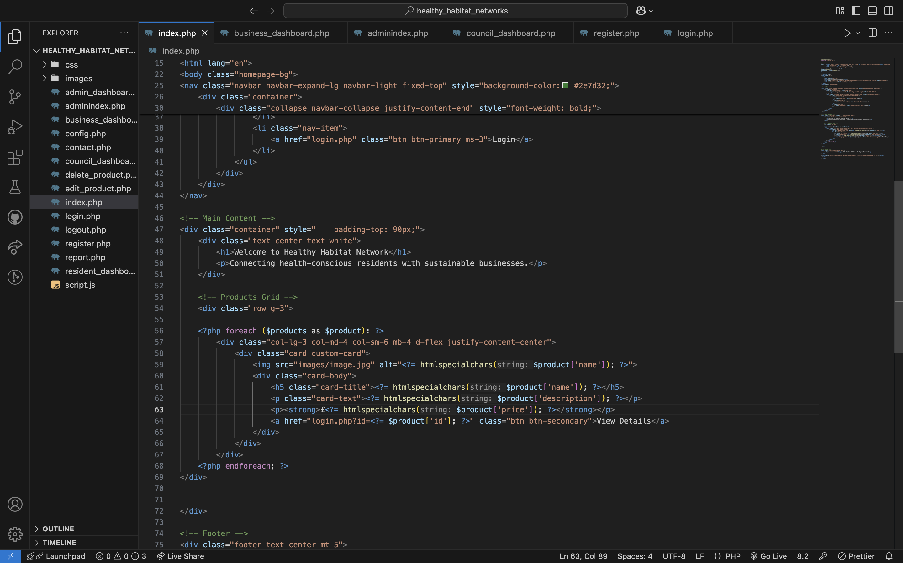

# Voting

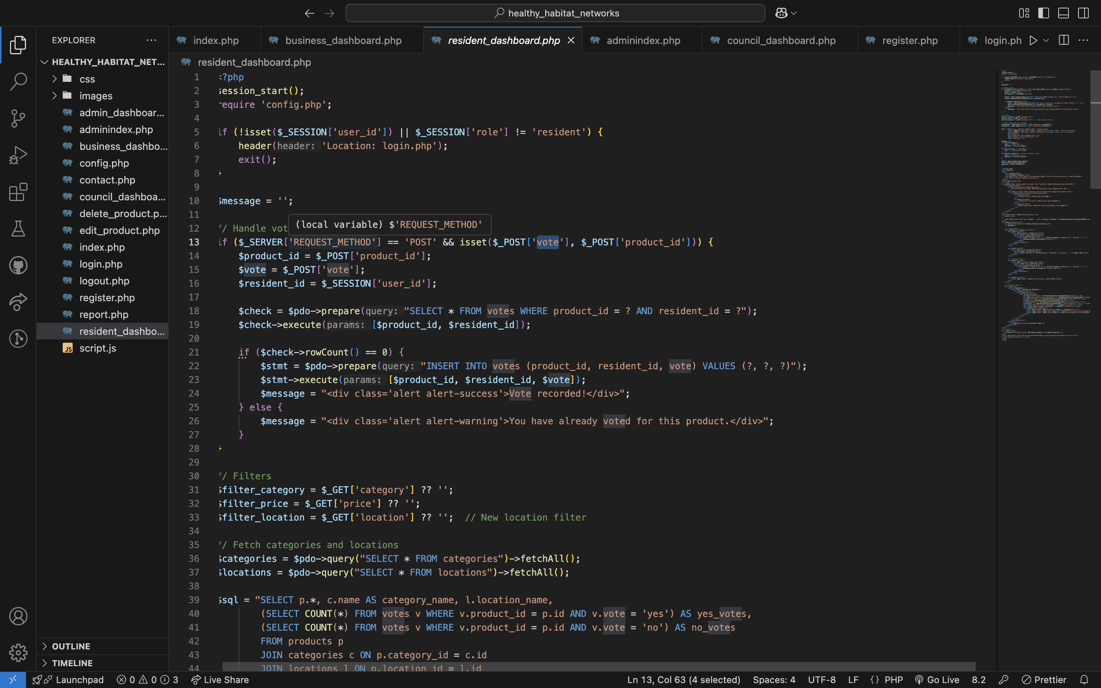

# Database

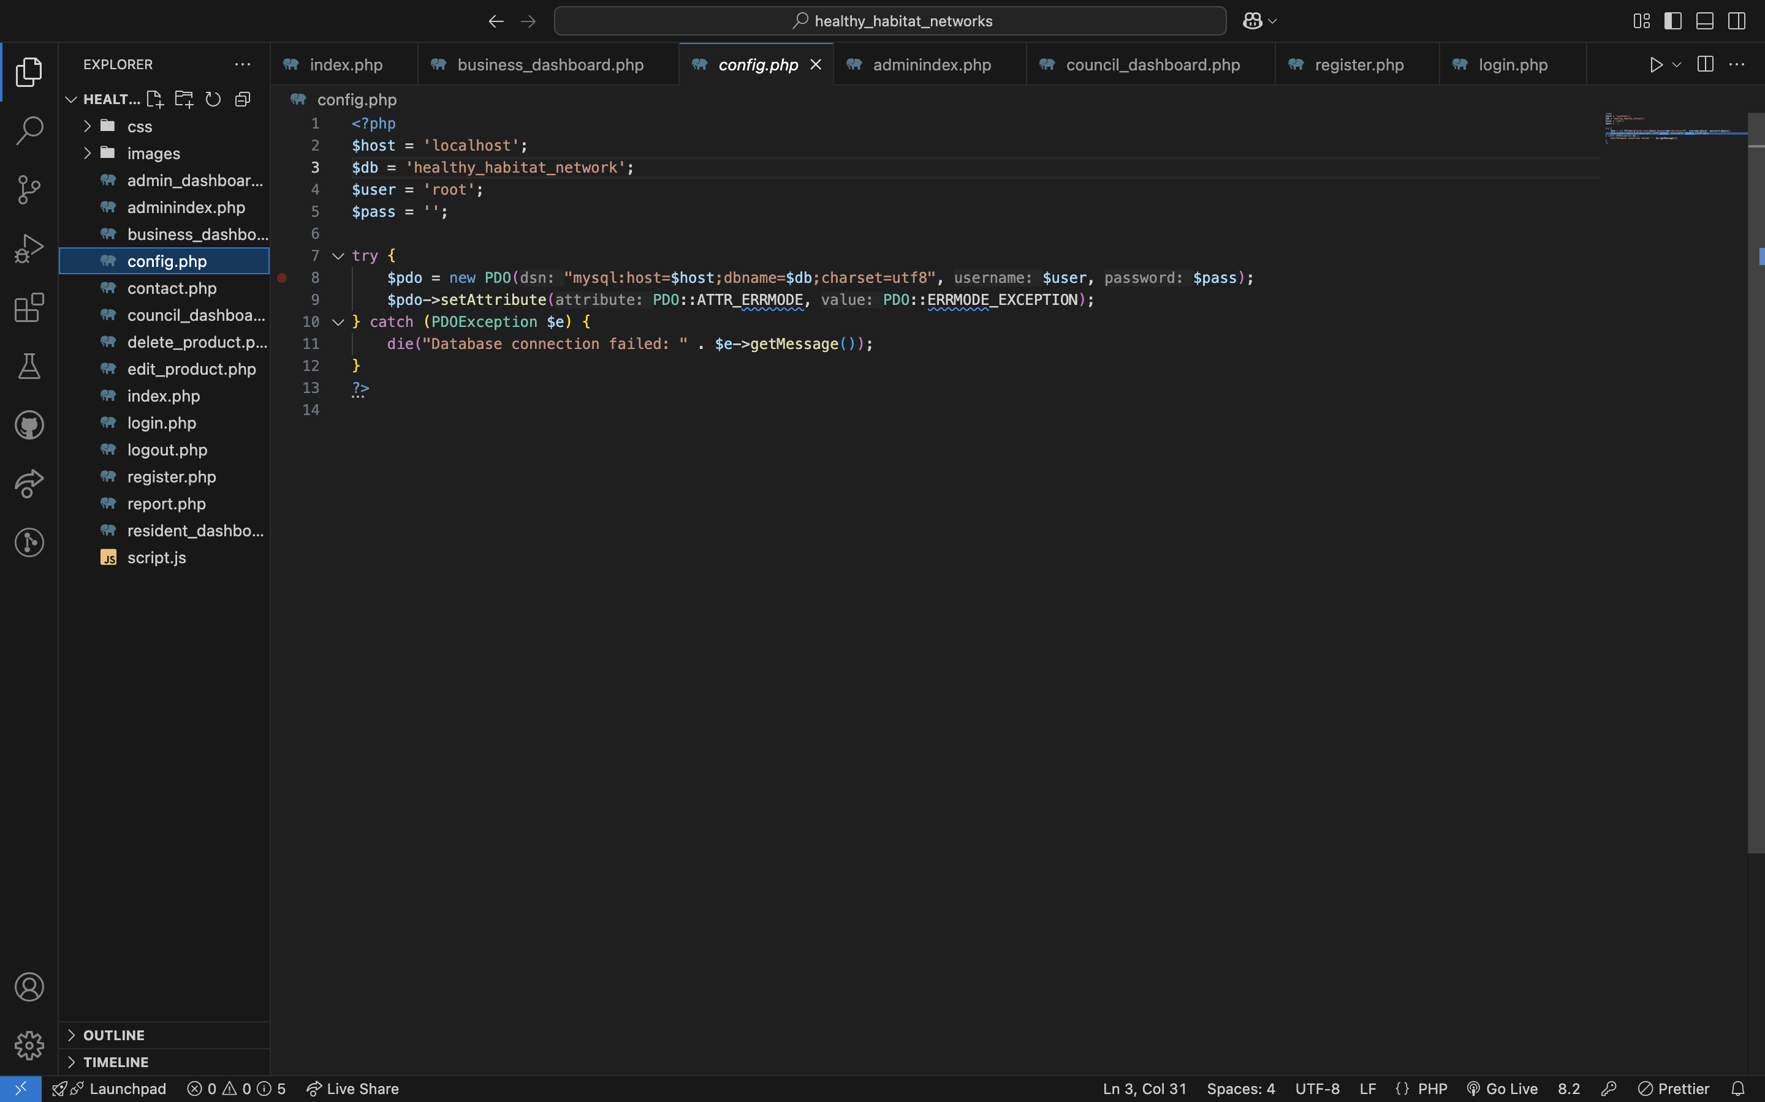

# 5. Non-Functional Requirements

1. Usability: User-friendly interface.  
2. Performance: Pages should load within 2–3 seconds.  
3. Scalability: Handle more users, businesses, and products efficiently.  
4. Security: Secure user data, prevent SQL injection, and validate input.  
5. Reliability: Stable system operation.  
6. Maintainability: Modular, well-documented code.  
7. Accessibility: Responsive design for all devices.  
8. Compatibility: Support modern browsers (Chrome, Firefox, Edge).  
9. Data Integrity: Prevent data duplication/conflicts.  
10. Backup and Recovery: Regular database backups and recovery mechanisms.

# Login

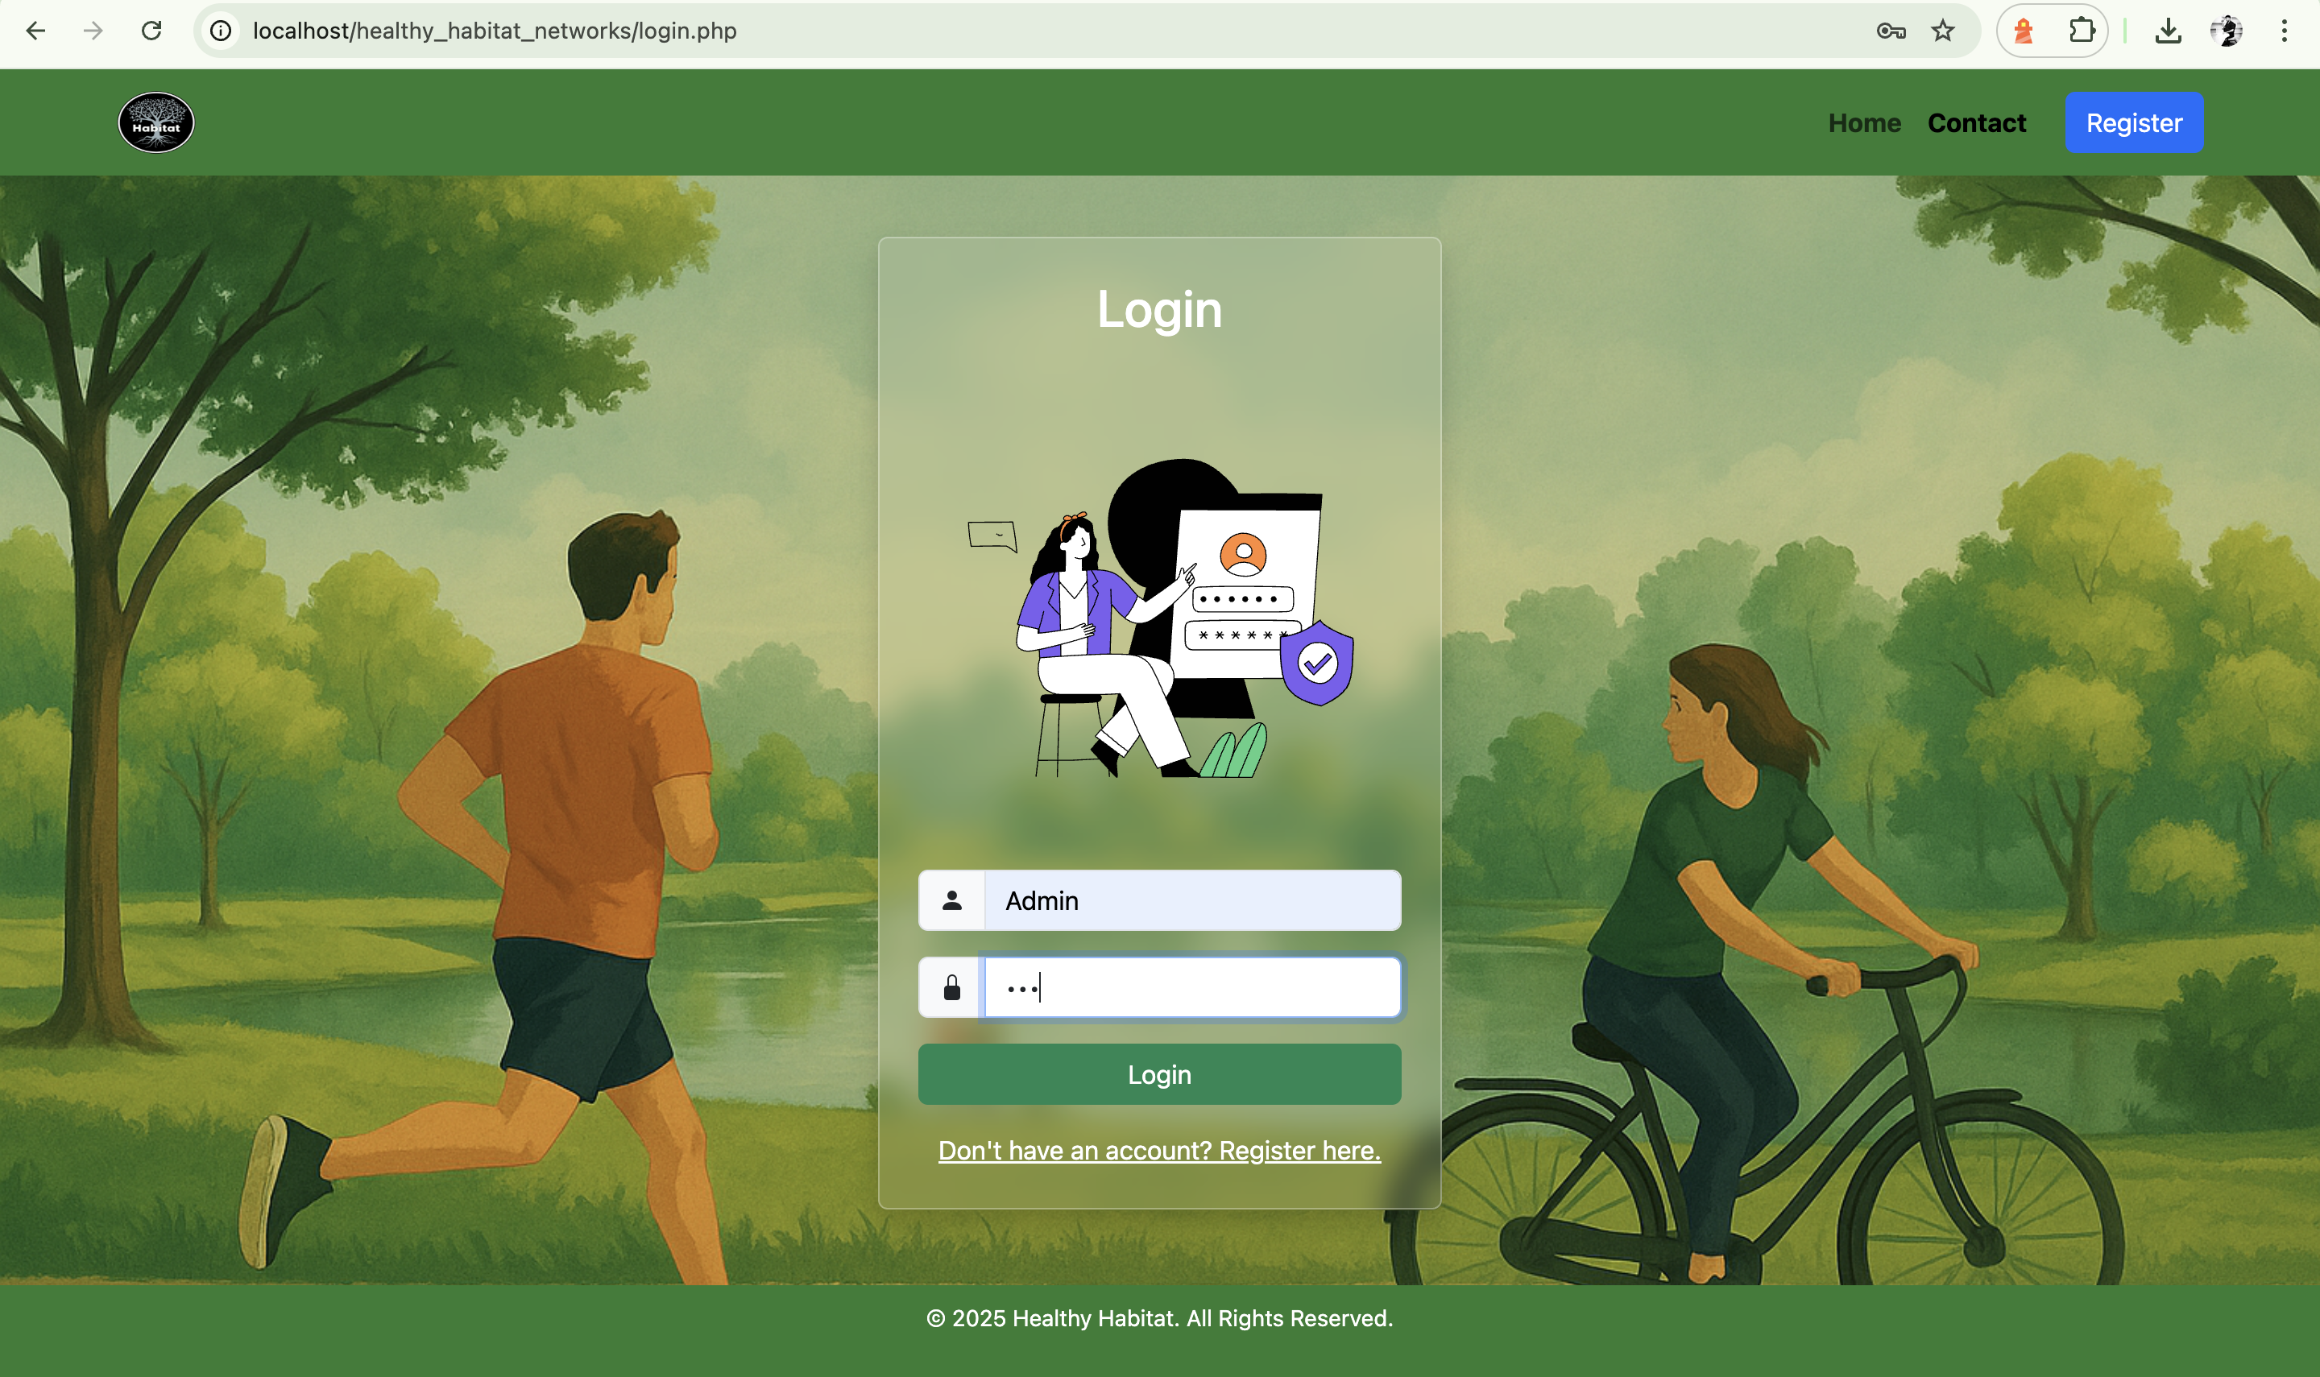

# Registration

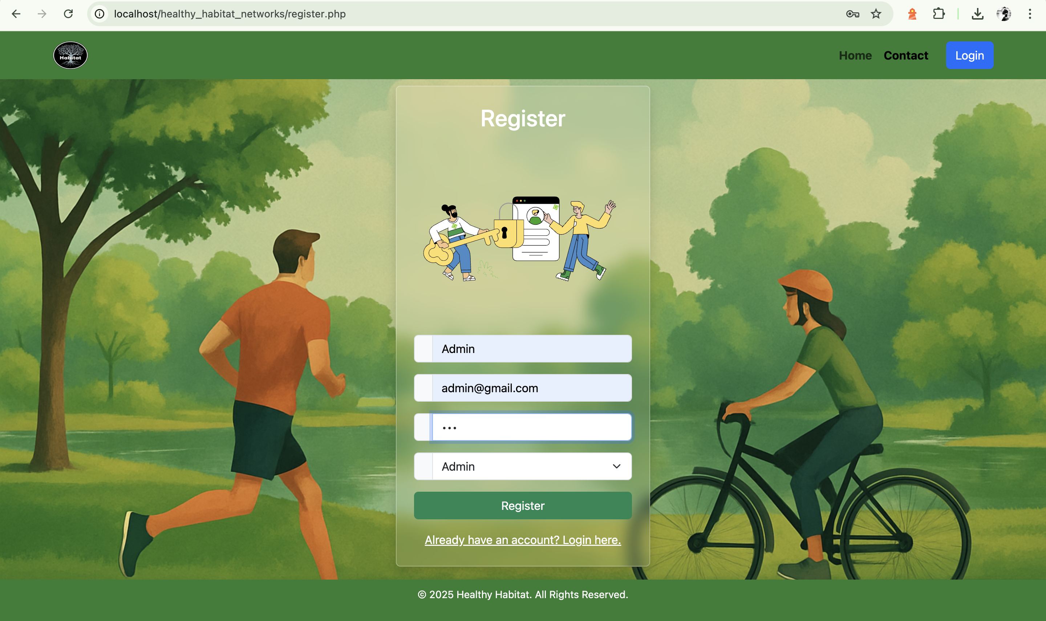

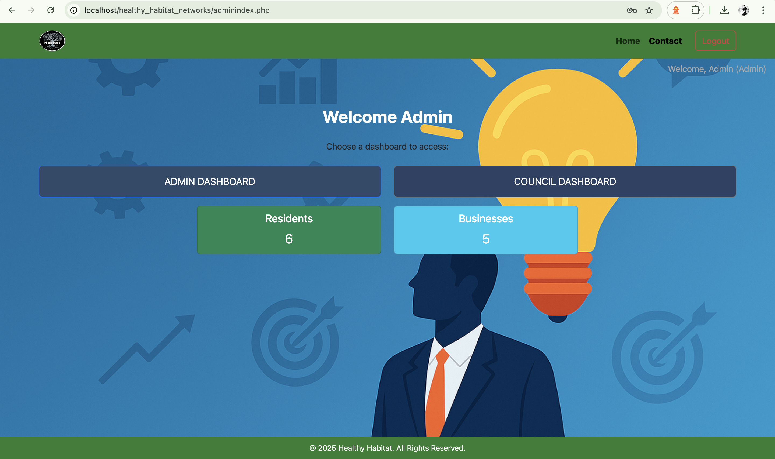

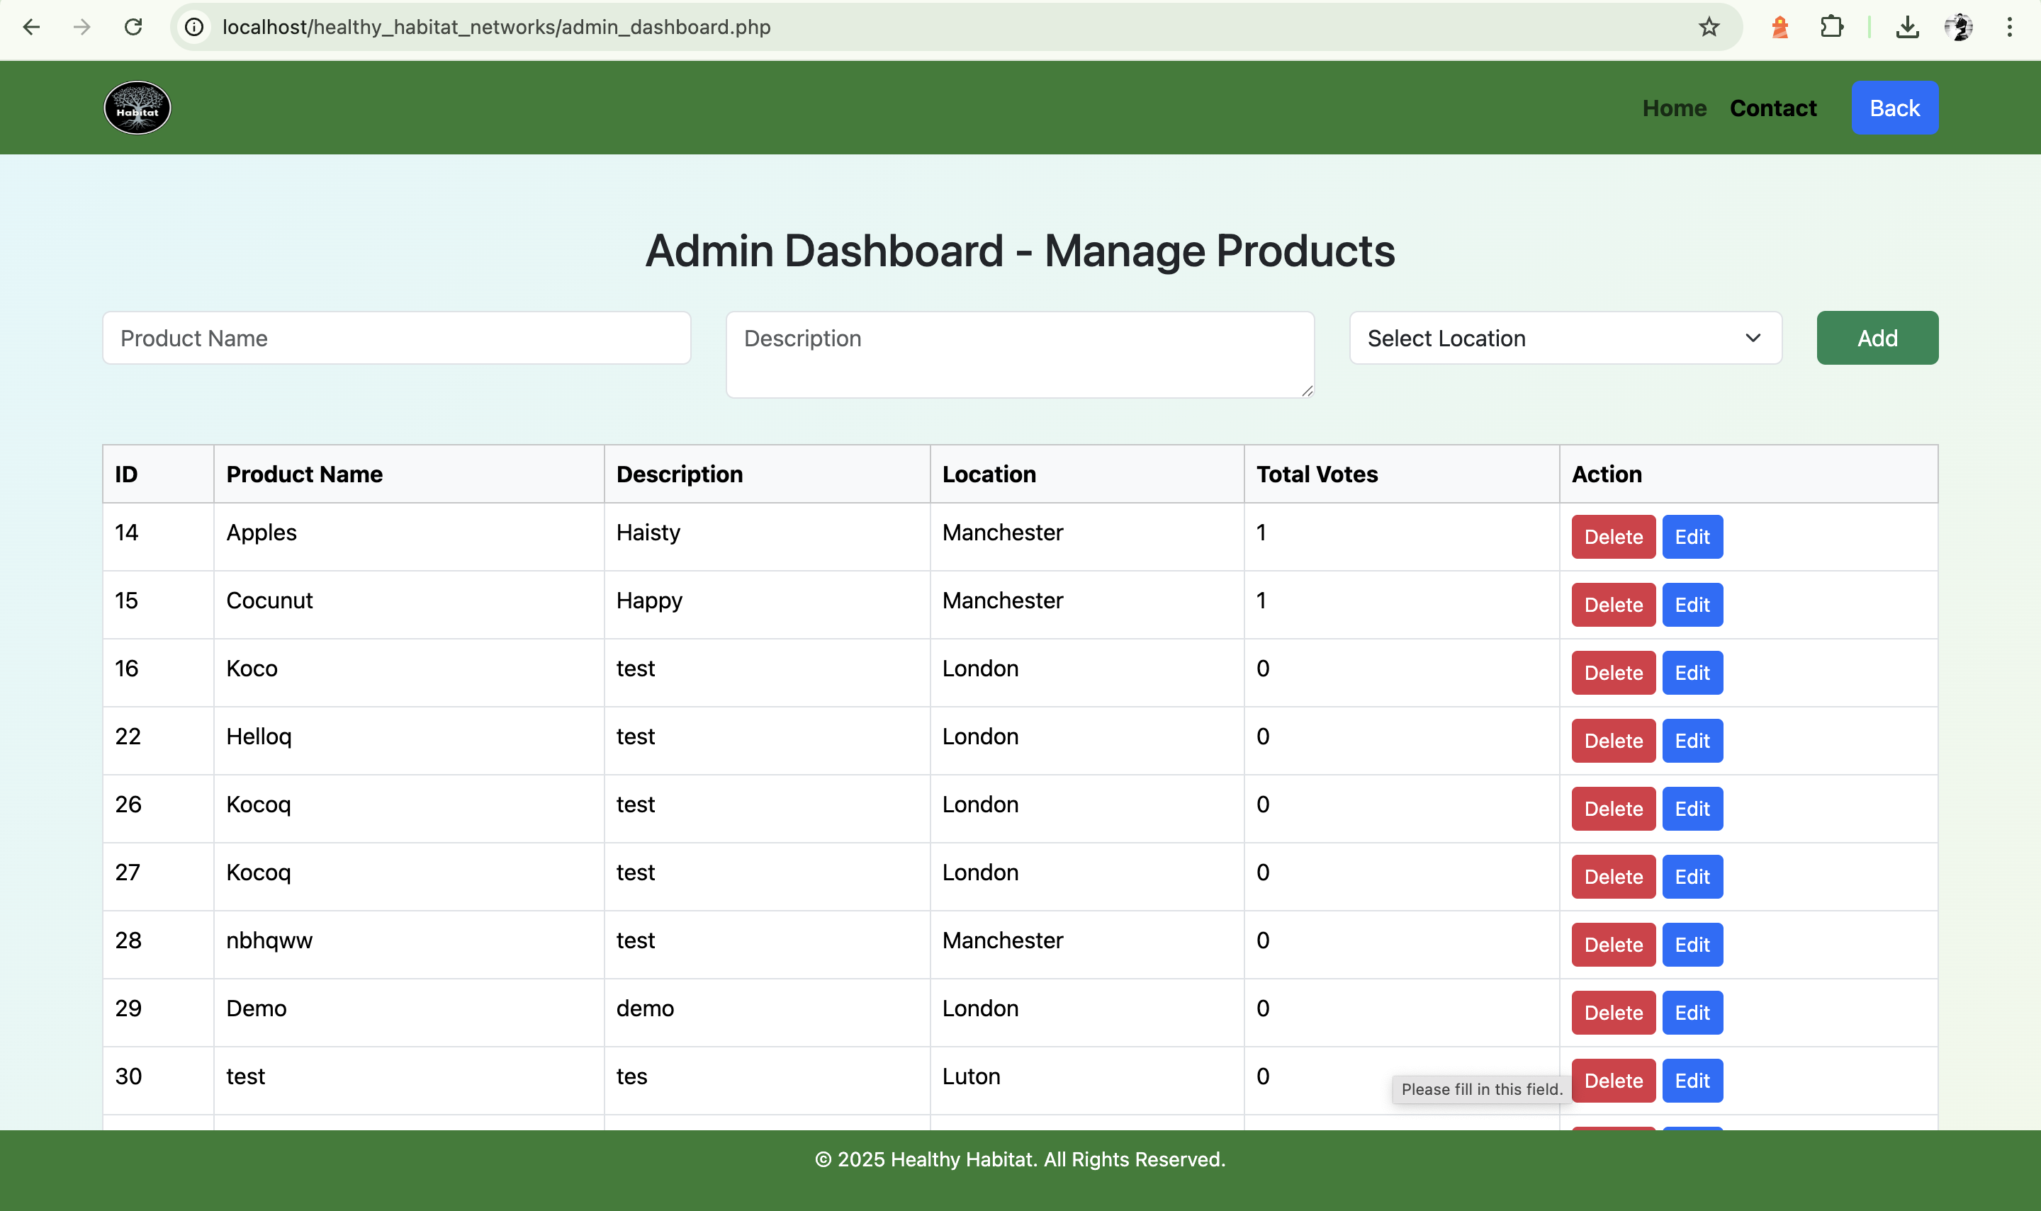

# 6. Outcome

The Healthy Habitat Network project successfully resulted in a web-based prototype that connects residents to health and well-being businesses offering sustainable products and services.   
  
The system supports resident registration by area, product and service listings, and a voting mechanism highlighting community preferences.  
  
Developed entirely using PHP, MySQL, HTML, CSS, and JavaScript, the prototype is scalable, user-friendly, and aligned with good usability practices. It lays a strong foundation for future development into a full-fledged community wellness center.

# 7. Roles and Responsibilities

Each team member contributed to the success of the **Healthy Habitat Network** project by taking on distinct roles. Below are the roles and specific responsibilities of each team member:

* **Umesh** – **Full-stack Developer** & **Requirement Engineer**
  + Developed both front-end and back-end components of the platform using PHP, MySQL, HTML, CSS, and JavaScript.
  + Gathered, defined, and documented project requirements, ensuring alignment with the project goals.
  + Created and managed the Trello board for tracking progress and task assignments.
* **Joyal** – **Full-stack Developer** & **Project Manager**
  + Managed both the back-end and front-end development of the platform, ensuring technical requirements were met.
  + Led project management activities, organised tasks, set deadlines, and monitored progress to ensure timely completion.
  + Contributed to the overall system architecture and database design
* **Hasan** – **Front-end Developer** & **Documentation**
  + Led the development of the user interface (UI) and ensured that the design was visually appealing, responsive, and user-friendly.
  + Acted as a bridge between team members to ensure clear communication and resolve issues as they arose.
  + Contributed to the overall project documentation, preparing the content and writing detailed sections to explain the development process.
* **Hope** – **Product Owner** & **Tester**
  + Acted as the liaison between the client (Healthy Habitat Network) and the development team, ensuring all requirements were clearly understood and met.
  + Led the testing process, including creating test cases, conducting quality assurance (QA), and ensuring the product was bug-free and functional.
* **Janvi** – **Tester** & **Documentation**
  + Assisted with testing and quality assurance by identifying bugs and issues within the platform and working with the development team to resolve them.
  + Contributed to writing and editing documentation, ensuring that the report was clear, coherent, and well-organised.

# 8.Trello Screenshots

Below are the three stages of the Trello Kanban board:

**• Screenshot 1: Beginning of Development**

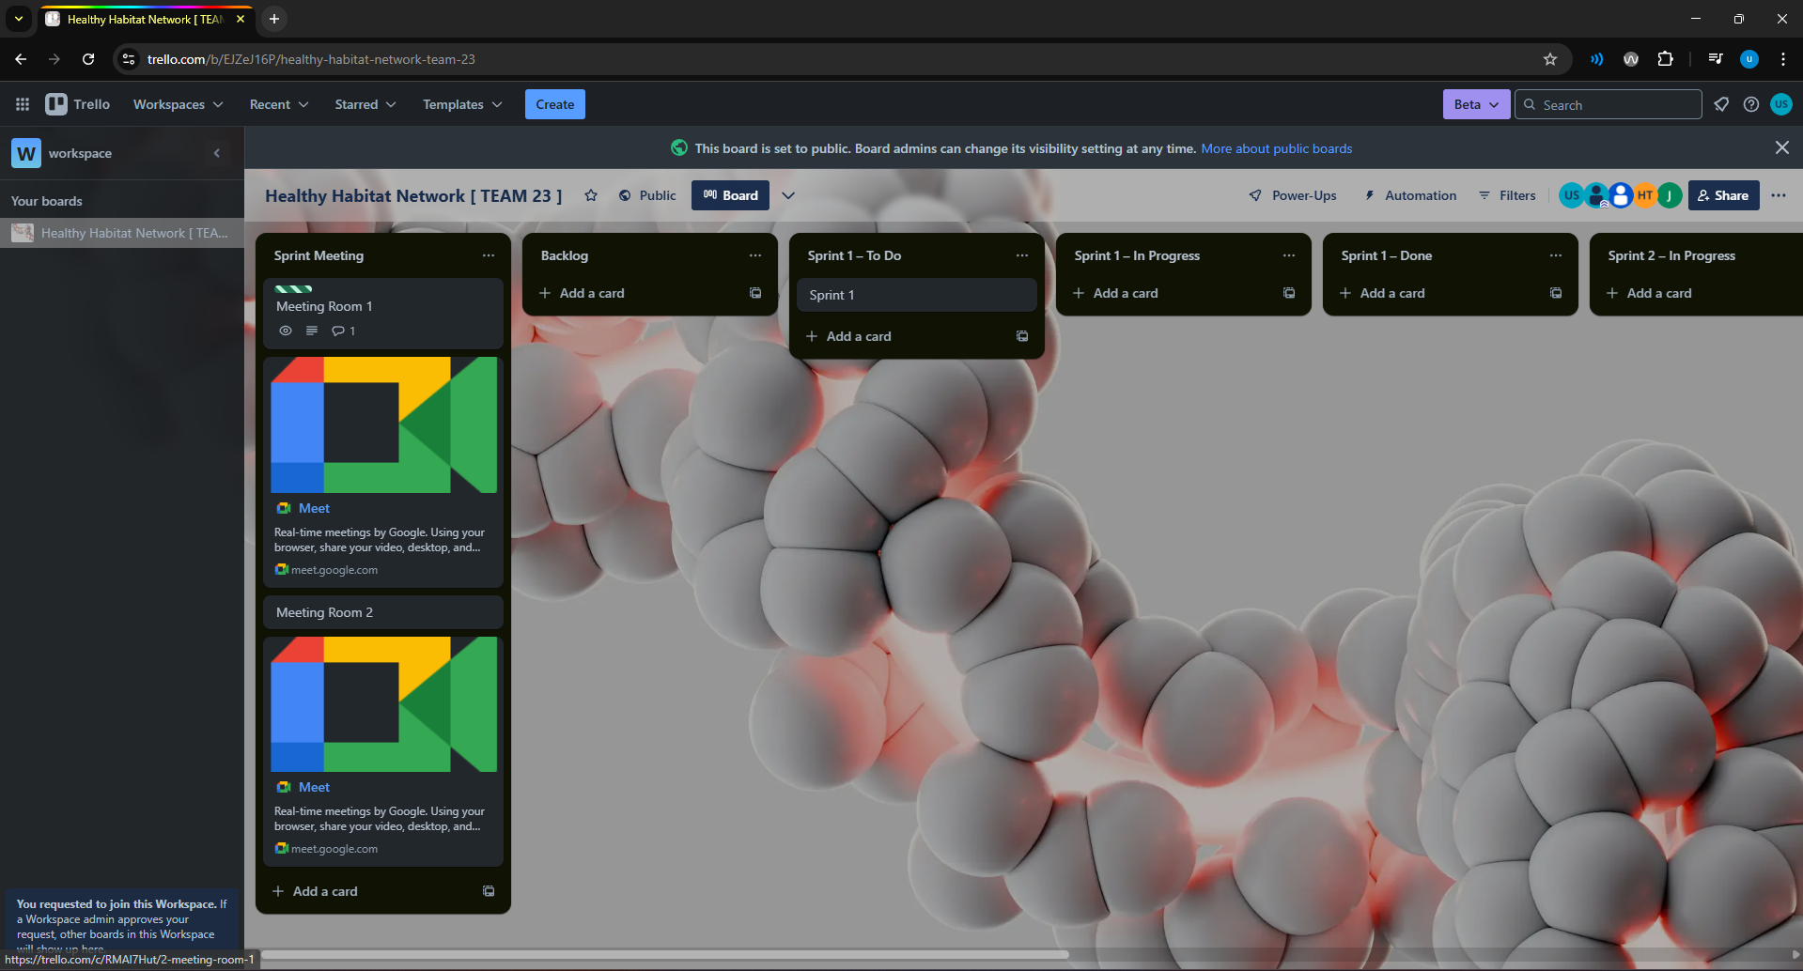

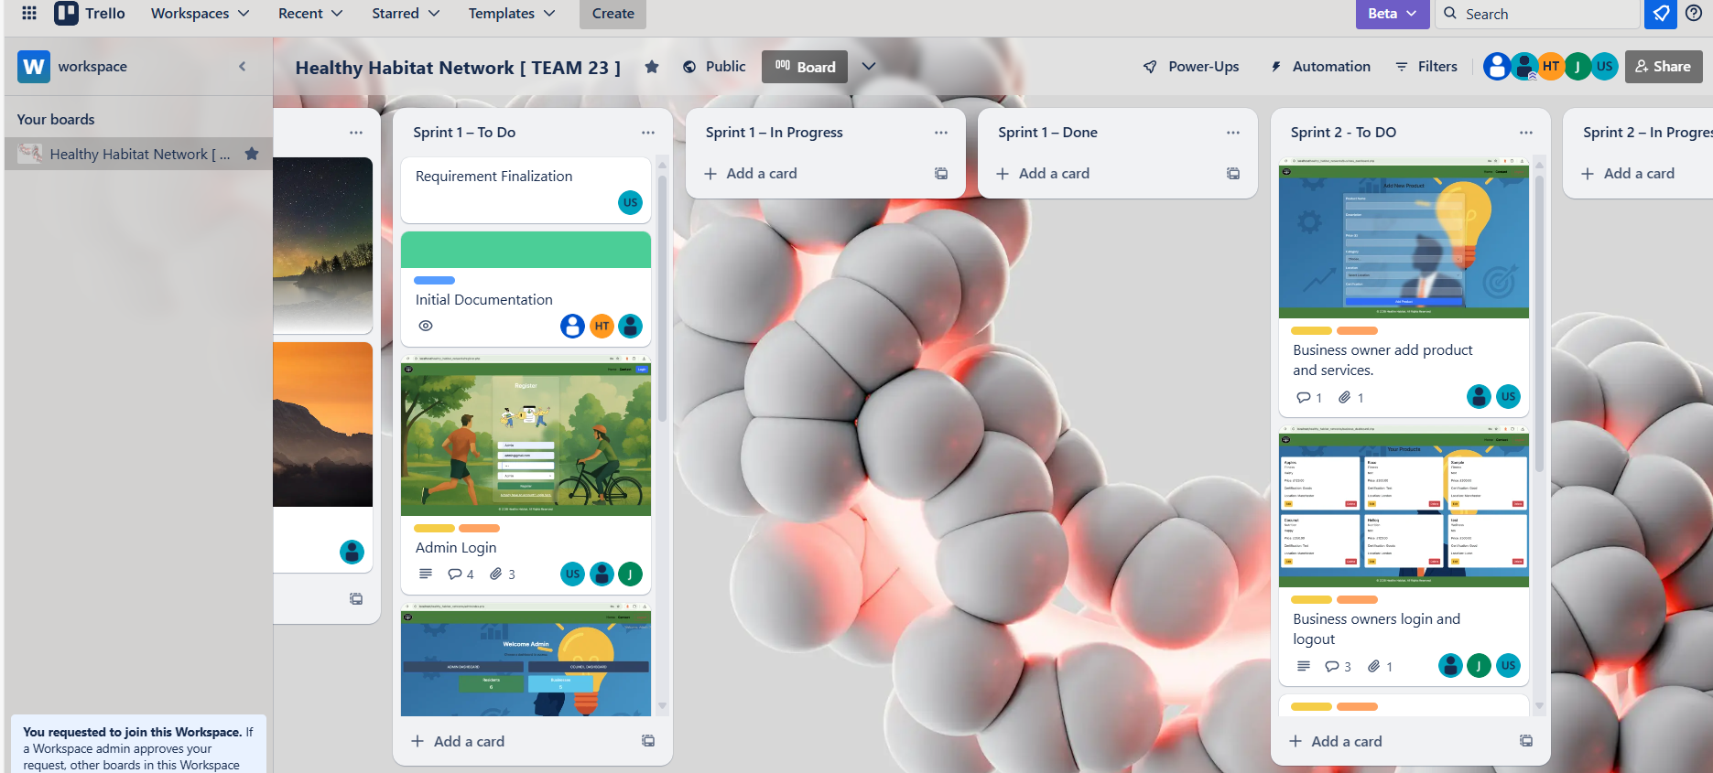

• **Screenshot 2: Middle of Development**

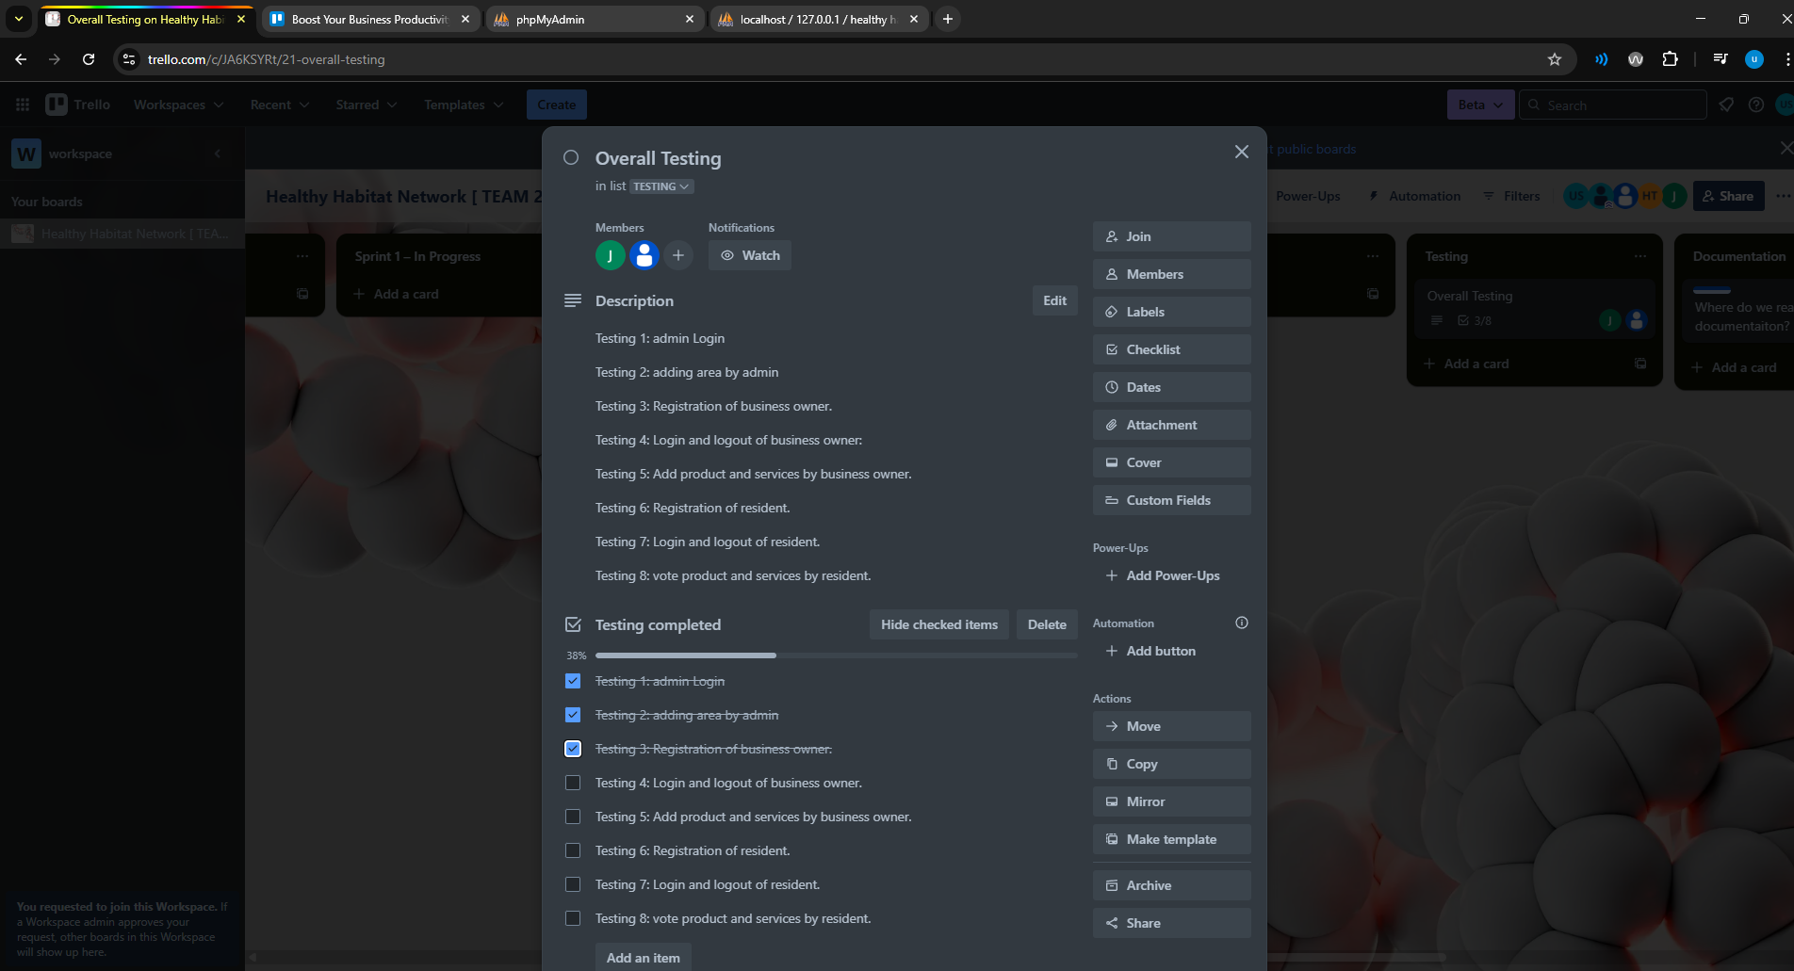

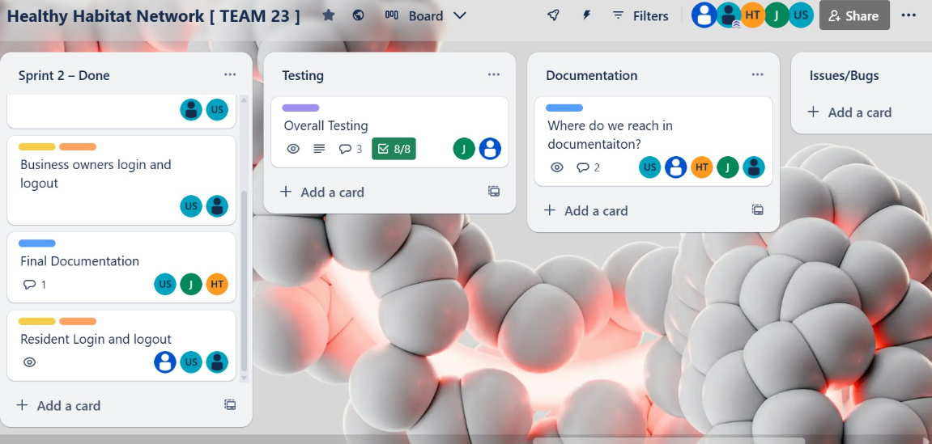

[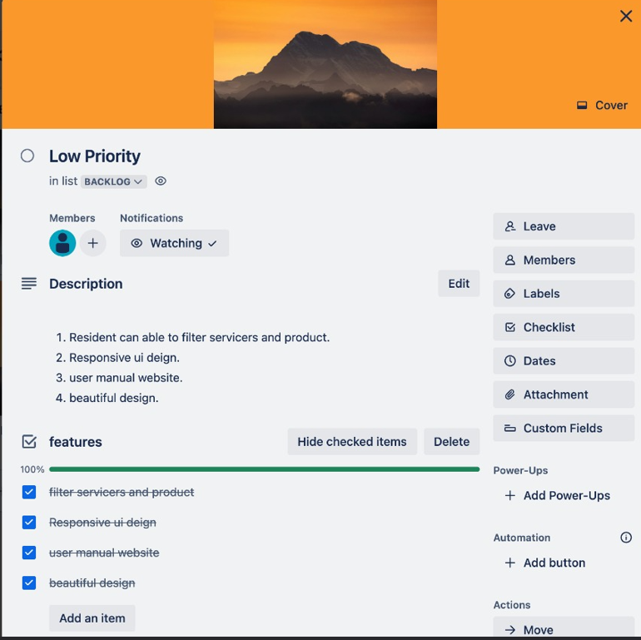

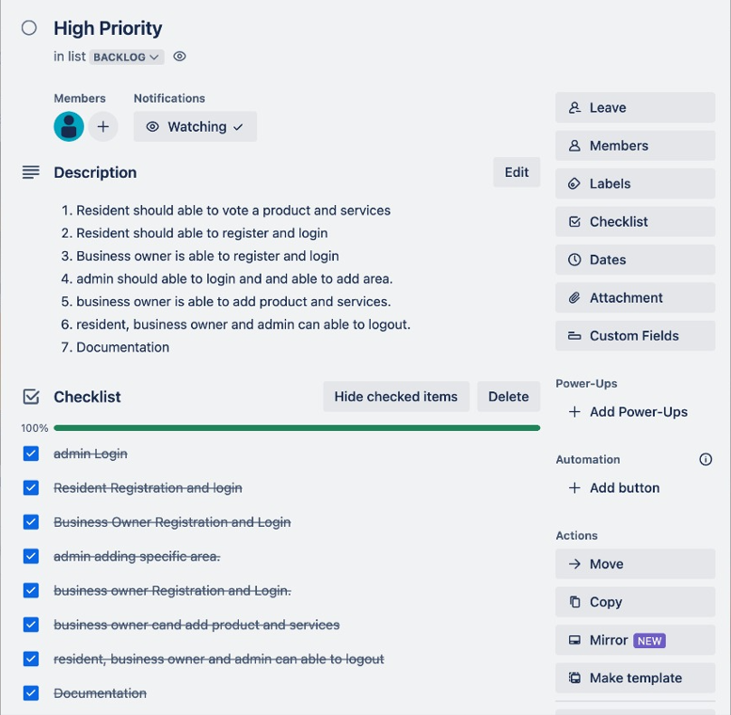

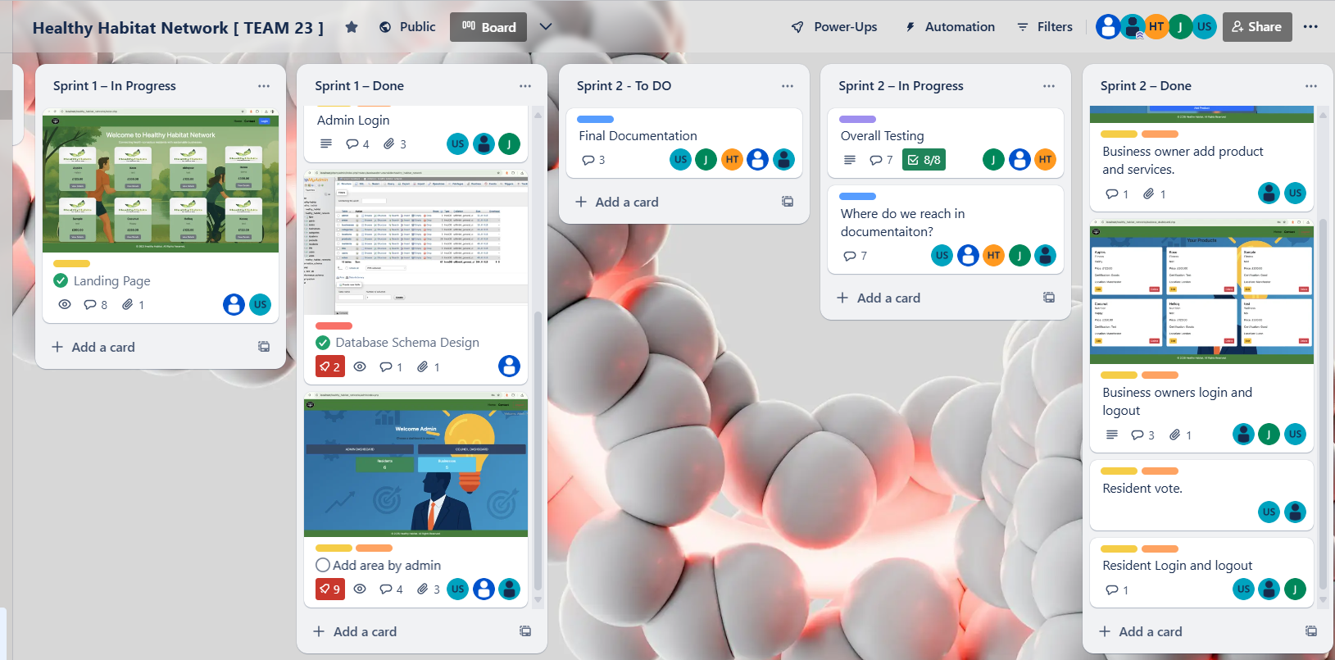

**Screenshot 3: Final Stage (Completed Tasks)**

